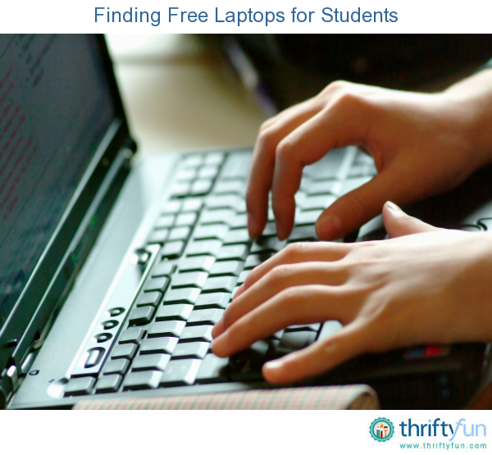
Fami
Help with Family Law Problems
wit

D

Do you need help with court forms and processes? Do you wonder if you have options other than going to court?

Come with your questions!

Meadow Lake Salvation Army Office
212 2nd St W., Meadow Lake
1:00 – 4:00 p.m.
Wednesdays: September 28, October 26, November 23, and December 14, 2022
No registration is required.
For more information, contact familylaw@gov.sk.ca or call 1-888-218-2822 (ext. 2)

